**Validation**

Please follow the below examples to validate that you have successfully installed the Affirm cartridge.

**Business Manager:**

All cartridge components are located in "Merchant Tools -> Site Preferences -> Custom Site Preference -> AFFIRM_PAYMENT".

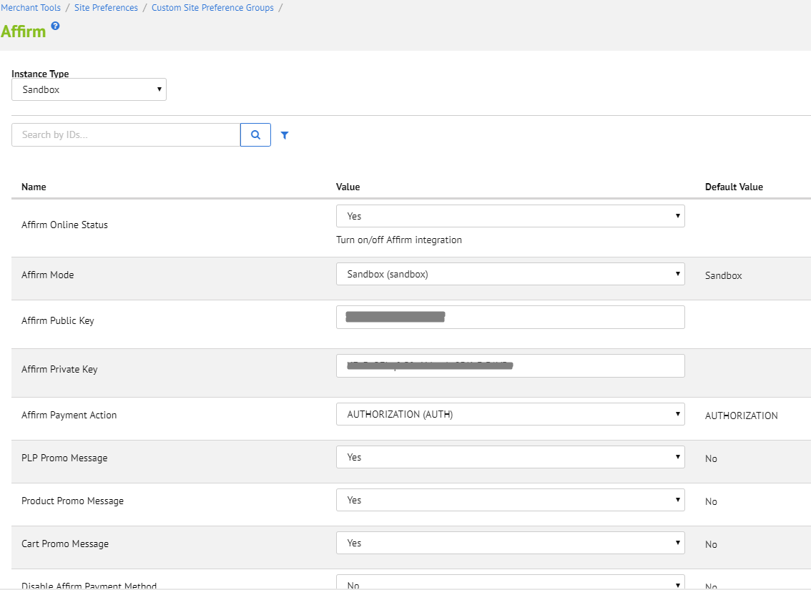

Set Affirm online status. Specify your Public and Private Keys. Provide your financial program details such as dates, customer groups, amount ranges. You can also choose if you want to add affirm promo messages to your store.

If PLP affirm promo is enabled, each product on category page will have affirm advertising message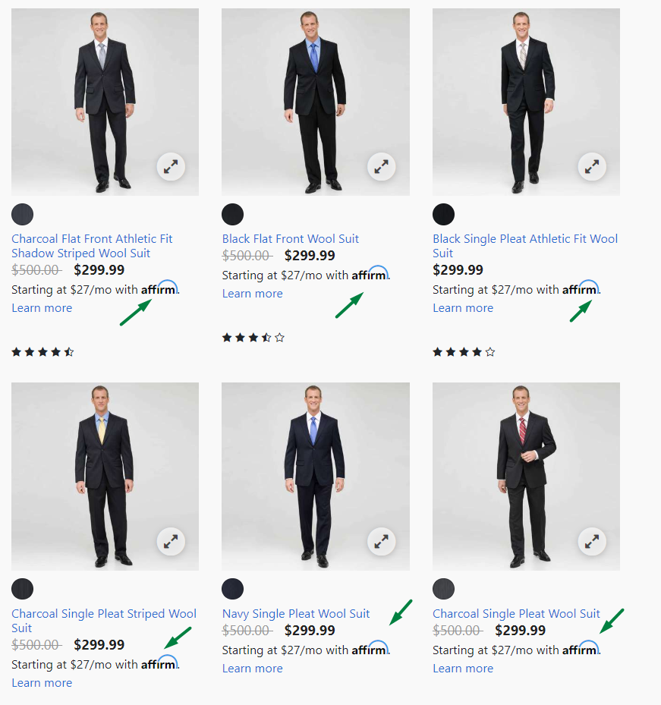

Product detail page will contain express checkout products (only for available products).

Also affirm promo message will be displayed in case relevant option was picked in site custom preferences

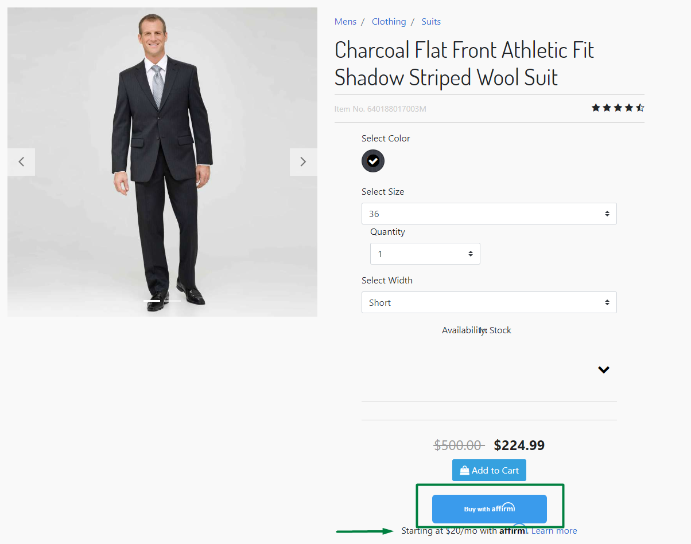

Same button will be present in cart and on quickView page

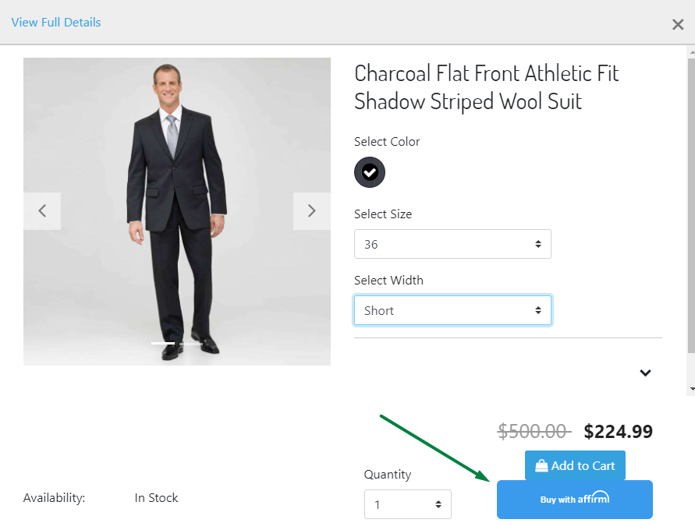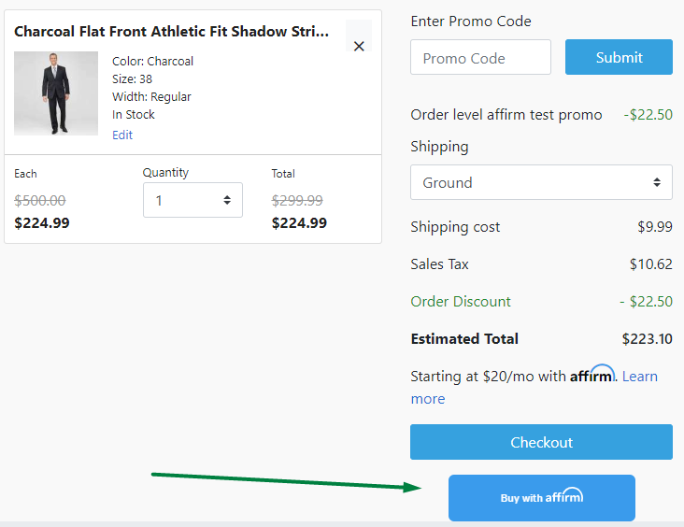

Express checkout button allows to proceed purchase through affirm modal window.

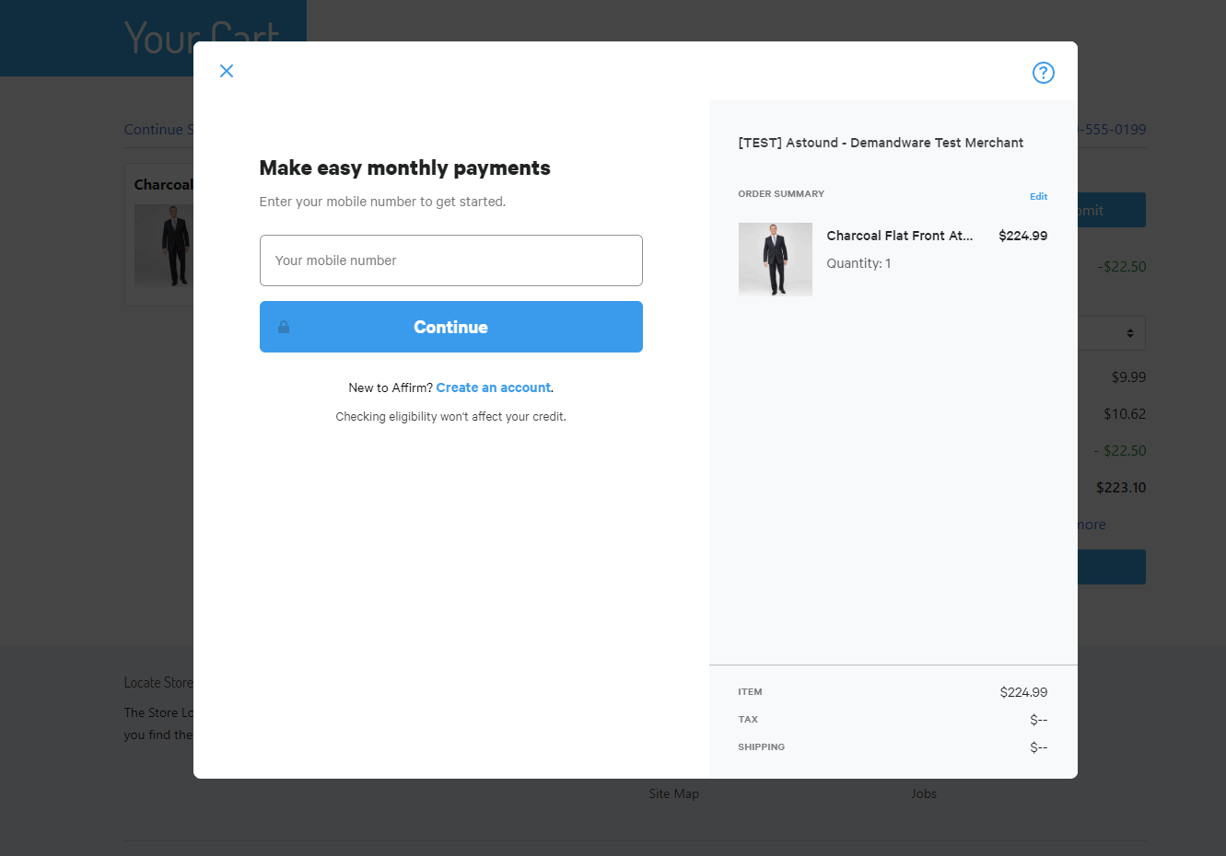

Also Affirm will be available as a payment method during normal checkout process